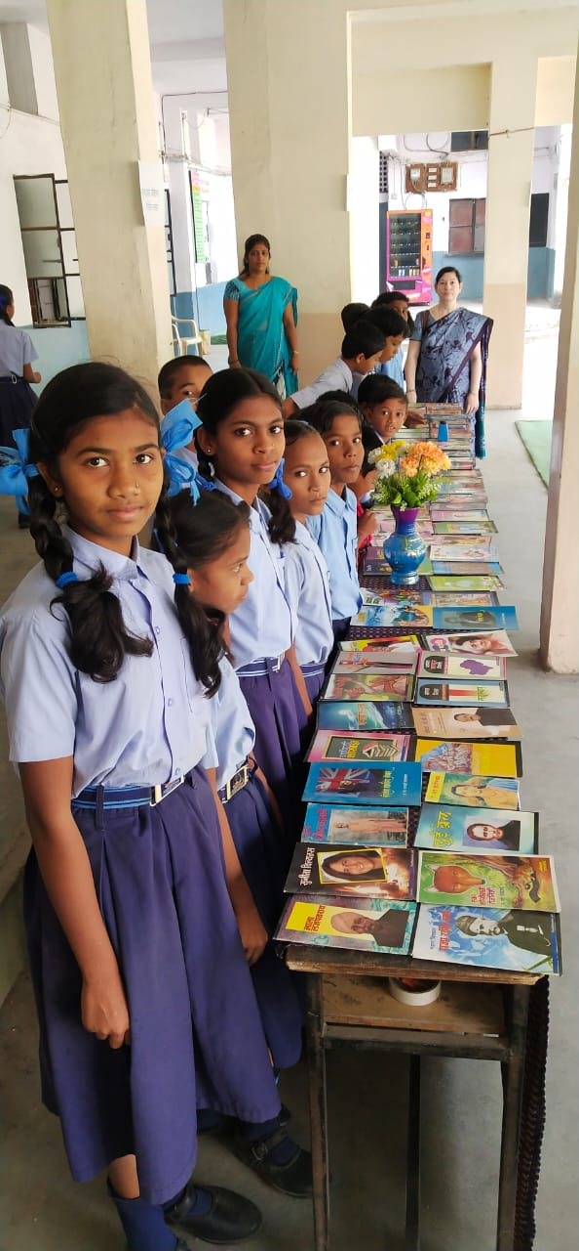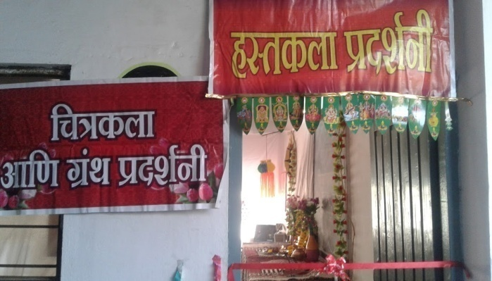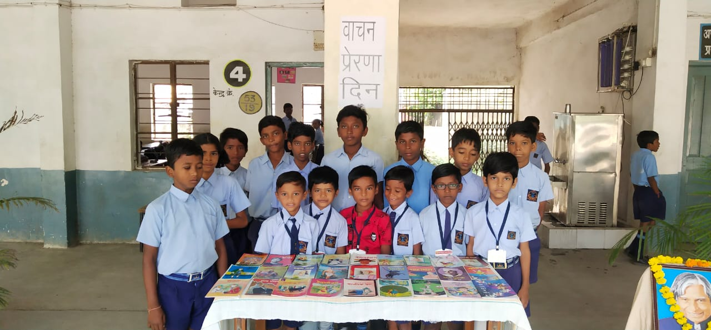 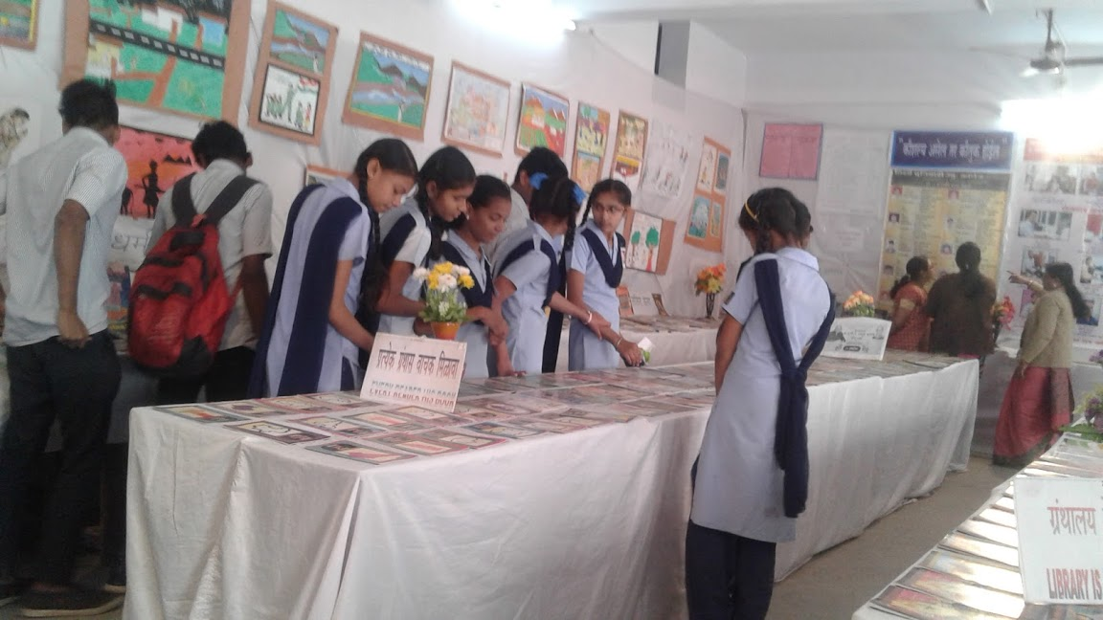

WEL COME TO VIDARBHA BUNIYADI HIGH SCHOOL & JR. COLLEGE LIBRARY

**LIBRARY STAFF**

**LIBRARIAN LIBRARIAN**

**ANIL T. MATHURE Smt. MAYA L. DEVIKAR**

**B.COM., M. LIB. I. SC. H. S.C. CER. OF LIB. SCI.**

**uos “kS{kf.kd /kksj.k vkf.k “kkys; xzaFkky;**

jkT;kP;k uohu “kS{kf.kd /kksj.kkr fo|kF;kZpk O;fDreRRokpk fodkl dj.;koj vkf.k f”k{k.k vf/kdkf/kd O;olk;kfHkeq[k dj.;koj Hkj ns.;kr vkyk vkgs- fo|kF;kZP;k O;fDreRRokP;k iw.kZ fodklklkBh “kkGkrwu ^lkekU; Kku* gk fo’k; lDrhpk dsyk vkgs- vk/kqfud dkGkr lkekU; Kkukps Lo#i ,o<s O;kid >kys vkgs dh] rks fo’k; ikB~;iqLrdkr fdaok osGki=dkP;k pkSdVhr cafnLr d#u Bsork ;s.;klkj[kk ukgh- gk fo’k; dkylkis{k vlY;keqGs fo|kF;kZaP;k eukrhy “kadk ] dqrwgy] ftKklk “kefo.;klkBh R;kauk xzaFkky;krwu vR;k/kqfud ekfgrh miyC/k d#u |koh ykxsy- izR;sd fo’k;kP;k vuq’kaxkus fo|kF;kZauk goh vlysyh ekfgrh ns.;kps dke fo’k; f”k{kd d# “kdyk rjp fo|kF;kZauk [kÚ;k vFkkZus lkekU; Kku feGw “kdsy- f”k{kdkyk gs v/;kiukps dke ;ksX; izdkjs djrk ;kos Eg.kwu “kkGsr le`/n xzaFkky; o f”k{kdkauk mRre lkFk ns.kkjk tk.kdkj xazFkiky vlk;yk gok-

ufou vH;kldzekP;k mfí’Vkaizek.ks fo|kF;kZps O;fDreRRo ?kMfo.;klkBh v/;;u v/;kiukr vusdfo/k ek/;ekapk okij >kyk ikfgts- f”k{kdkauh Lor% vk/kh [kwi okpu dsys rjp rs fo|kF;kZauk ufou vHlkldzekr vfHkizsr vlysys lkekU; Kku izkIr d#u nsÅ “kdrhy- xzaFkky; lkfgR; vkt dsoG eqfnzr lkfgR;kiqjrsp ek;kZfnr jkfgysys ukgh- ufou vHlkldzekps mfí’V lk/; dj.;klkBh “kkGsr loZ izdkjP;k Kku lk/kukauh le`/n vlysys xzaFkky; vlk;yk gos-

**“kkys; xzaFkky;kph mfí’Vs**

**1 “kkGsrhy f”k{kd vkf.k fo|kFkhZ ;kauk R;kaP;k v/;kiu vkf.k v/;;uklkBh**

**vko”;d vlysys xzaFk vkf.k brj lkfgR; miyC/k d#u ns.ks vkf.k R;kpk vf/kdkf/kd okij gks.;kP;k n`’Vhus O;oLFkk dj.ks**

**2 fo|kF;kZae/;s okpukph vkoM fuekZ.k dj.ks ] R;kauk okpukr ekxZn”kZu d#u Lora=i.ks KkuktZu**

**dj.;kl izo`Rr dj.ks-**

**3 fo|kF;kZauk xzaFkky;kpk okij dj.;kps f”k{k.k ns.ks-**

**4 fo|kF;kZps Nan] vkoMh tksiklwu R;kapk O:fDreRRokpk fodkl dj.ks] R;kauk izksRlkgu ns.ks-**

**5 xzaFkky; lkfgR; vkf.k xzaFkky; midzekauk izfl/nh nsÅu xazFkky;kpk okij vf/kdkf/kd gks.;kP;k**

**n`’Vhus iz;Ru dj.ks-**

**6 fo|kF;kZae/;s ijLij lgdk;kZph Hkkouk fuekZ.k dj.ks-**

**“kkys; xzaFkky;hu lsok**

1. **xzaFk nso?kso**
2. **lanHkZ lsok**
3. **ekfgrh lsok**
4. **o`Rri= dk=.k lsok**
5. **fu;rdkfyd vuqdzef.kdk lsok**
6. **xazzFkky; rkl**

**xzaFkky;kps dkgh midze**

**xzaFk izn”kZu**

**okpu isVh**

**fu;rdkfyds o o`Rri=s**

**Li/kkZijh{kk iqLrds**

**O;olk; ekxZn”kZu xzaFk**

**xzaaFklaxzg**

**vkeP;k “kkys; xzaFkky;kr oxZ 5 rs 12 ph vH;kldze iqLrds fofo/k fo’k;kojhy lkfgR;] xazFk] lanHkZ xzaFk] cky lkfgR;] vls lqekjs 10000 xzaFkky; lkfgR; fo|kFkhZ o f”k{kdkadjhrk miyC/k vkgsr-**

**vH;kldze iqLrds**

**oxZ 11 ok o 12 ok dyk ] okf.kT; o foKku**

**oxZ 11 ok o 12 ok O;kolkf;d vHlkldze**

**vokarj xzFk laxzg**

**[lkekU; Kku] rRRoKku] /keZ] lkekftd “kkL=s] Hkk’kk] foKku] ra=foKku ] fofo/k dyk] ejkBh lkfgR;] ejkBh dfork] ukVd] dknacjh] dFkklaxzg fofo/k ys[k laxzzg] fganh lkfgR;] dfork] ukVd] dFkklaxzg o dknacjh] baxzth lkfgR;] bfrgkl o Hkwxksy] pfj= o vkRepfj=s] cky dFkk laxzg] cky pfj=s bR;knh](New%20Microsoft%20Office%20Excel%20Worksheet.xlsx)**

**o`Rri=s %** [**yksder**](http://www.epaper.lokmat.com) **epaper.lokmat.com, yksd”kkgh okrkZ] uoHkkjr**

**fu;rdkfyds % f”k{k.k ladze.k ] yksdjkT; ] thouf”k{k.k] fd”kksj ] ejkBh foKku if=dk ] lkekU;Kku ]**

**Dream 2047 , MENTOR**

**fonHkZ cqfu;knh gk;Ldwy o dfu’B egkfo|ky;**

**xzaFkky;**

**¼ xzaFk laxzg % ,d n`’Vh{ksi ½**

**v-dz- fo’k; xzaFk la[;k**

1 lkekU; 125

2 rRRoKku 108

3 /keZ 124

4 lkekftd “kkL=a 215

5 Hkk’kk 25

6 foKku 142

8 ra=foKku 78

9 yfyrdyk 35

10 **ejkBh lkfgR;**

¼1½ ejkBh yfyr 83

¼2½ ejkBh dfork 131

¼3½ ejkBh ukVd 155

¼4½ ejkBh dknacjh 162

¼5½ ejkBh dFkklaxzg 128

11 pfj=a@vkRepfj=a 227

12 izoklo.kZu ¼bfrgkl] Hkwxksy½ 52

13 fganh lkfgR; 120

14 baxzth lkfgR; 25

**cky foHkkx**

dFkklaxzg 490

pfj=a 601